**Date:**

**EXPERIMENT-2**

**IMPLEMENTATION OF STAR TOPOLOGY USING PACKET TRACER**

**Aim:** To Implement a star topology using packet tracer and hence to transmit data between the devices connected using star topology.

**Software/Apparatus required:** Packet Tracer/End devices, bridge, connectors.

**Steps for building topology:**

**Step 1: Start Packet Tracer**

**Step 2: Choosing Devices and Connections Step 3: Building the Topology – Adding Hosts**

Single click on the **End Devices**. Single click on the **Generic** host. Move the cursor into topology area.

Single click in the topology area and it copies the device.

**Step 4: Building the Topology – Connecting the Hosts to Switches**

Select a switch, by clicking once on **Switches** and once on a **2950-24** switch. Add the switch by moving the plus sign “**+**”

**Step 5: Connect PCs to switch by first choosing Connections**

Click once on the **Copper Straight-through** cable Click once on **PC2**

Choose **Fast Ethernet** Drag the cursor to **Switch0** Click once on **Switch0**

Notice the green link lights on **PC** Ethernet NIC and amber light **Switch port**. The switch port is temporarily not forwarding frames, while it goes through the stages for the Spanning Tree Protocol (STP) process. After about 30 seconds the amber light will change to green indicating that the port has entered the forwarding stage. Frames can now forwarded out the switch port.

**Step 6: Configuring IP Addresses and Subnet Masks on the Hosts**

To start communication between the hosts IP Addresses and Subnet Masks had to be Configured on the devices. Click once on PC0. Choose the Config tab and click on

FastEthernet0. Type the IP address in its field. Click on the subnet mask it will be generated automatically.

**Step 7: To confirm Data transfer between the devices**

Click on the node. Select desktop option and then command prompt. Once the window

pops up, ping the IP address of the device to which node0 is connected. Ping statistics

will be

displayed.

**Diagram:**

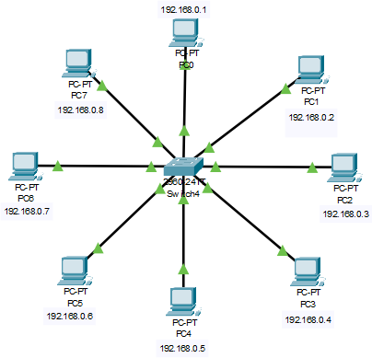

**Output:**

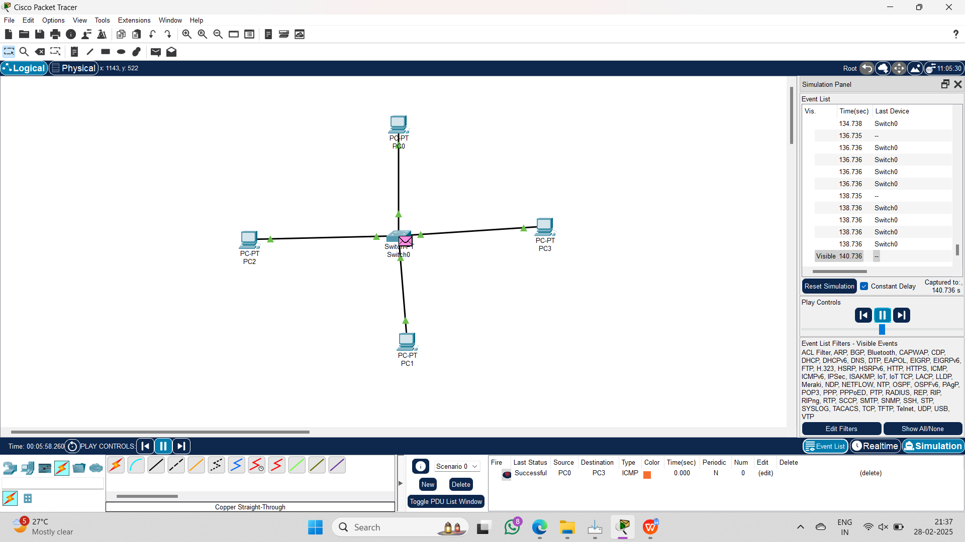

**Result:** Thus the Star topology is implemented with Packet Tracer simulation Tool.